**DESIGN THINKING AND INNOVATION REPORT**

**entitled**

**wireless intrusion prevention system using esp 8266**

Submitted in partial fulfillment of the requirements for the award of

Bachelor of Engineering degree in Computer Science and Engineering with

specialization in ARTIFICIAL INTELLIGENCE

by:

HARISHSHANKAR A A

**Reg.No:**42731024



## DEPARTMENT OF COMPUTER SCIENCE AND ENGINEERING

**SCHOOL OF COMPUTING**

**SATHYABAMA**

## INSTITUTE OF SCIENCE AND TECHNOLOGY

## (DEEMED TO BE UNIVERSITY)

**Accredited with Grade “A++” by NAAC|12B Status by UGC| Approved by AICTE**

JEPPIAAR NAGAR, RAJIV GANDHISALAI,

CHENNAI – 600119.

**OCTOBER 2023**

**SATHYABAMA**

**INSTITUTE OF SCIENCE AND TECHNOLOGY**

## (DEEMED TO BE UNIVERSITY)

**Accredited with Grade “A++” by NAAC|12B Status by UGC| Approved by AICTE**

Jeppiaar Nagar, Rajiv Gandhi Salai,

Chennai – 600 119.

[**www.sathyabama.ac.in**](http://www.sathyabama.ac.in/)

## DEPARTMENT OF COMPUTER SCIENCE AND ENGINEERING

**BONAFIDE CERTIFICATE**

This is to certify that this Design Project / Product Report is the bonafide work of **Mr.HARISHSHANKAR (Reg.No.42731024)** who carried out the project entitled **“ wireless intrusion prevention system using esp 8266”** under my supervision from July 2023 to October 2023.

**Design Supervisor**

**Ms.G.Anbu Selvi,M.Tech.,(Ph.D)**

**Head of the Department**

**Dr. S. VIGNESHWARI, M.E., Ph.D.,**

**Submitted for Viva voce Examination held on ________________­­__**

**Internal Examiner External Examiner**

**DECLARATION**

I, **HARISHSHANKAR (Reg.No.42731024),** hereby declare that the Project/Product Design Report entitled**“ wireless intrusion prevention system using esp 8266”** done by me under the guidance of **Ms.G.Anbu Selvi,M.Tech.,(Ph.D)** is submitted in partial fulfilment of the requirements for the award of Bachelor of Engineering degree in Computer Science and Engineering with specialization in ARTIFICIAL INTELLIGENCE

**DATE:**

## PLACE: SIGNATURE OF THE CANDIDATE

**ACKNOWLEDGEMENT**

I am pleased to acknowledge my sincere thanks to **Board of Management** of **SATHYABAMA** for their kind encouragement in doing this project and for completing it successfully. I am grateful to them.

I convey my thanks to **Dr. T.Sasikala M.E., Ph.D.**, **Dean**, School of Computing, **Dr. S.Vigneshwari M.E., Ph.D., Head of the Department** **of** **Computer Science and Engineering** for providing me necessary support and details at the right time during the progressive reviews.

I would like to express my sincere and deep sense of gratitude to my Internal Guide **Ms.G.Anbu Selvi,M.Tech.,(Ph.D)** for her valuable guidance, suggestions and constant encouragement which paved way for the successful completion of my Design Project/Product.

I wish to express my thanks to all Teaching and Non-teaching staff members of the **Department of Computer Science and Engineering** who were helpful in many ways for the completion of the project.

**ABSTRACT**

The advent of wireless networks has revolutionized connectivity, but it has also introduced vulnerabilities to unauthorized access and security breaches. This paper introduces a Wireless Intrusion Prevention System (WIPS) employing the ESP8266 microcontroller, a cost-effective and versatile platform known for its robust wireless capabilities. The proposed system leverages the ESP8266's packet analysis capabilities to monitor network traffic, employing sophisticated algorithms to detect anomalous patterns indicative of potential threats. Through strategic sensor placement and supplementary modules like RF spectrum analyzers, the WIPS extends its detection capabilities to both electronic and physical intrusion attempts.

A key strength of this system lies in its real-time response mechanisms, allowing for immediate mitigation of detected threats. By automating actions such as blocking suspicious MAC addresses and adjusting firewall rules, the WIPS effectively neutralizes potential security risks. Furthermore, the scalability of the ESP8266-based solution enables seamless integration into various environments, from home networks to large-scale enterprise setups.

The proposed methodology encompasses stages ranging from hardware selection and firmware development to testing and validation. Rigorous testing measures, including simulated intrusion scenarios and stress tests, ensure the system's reliability and effectiveness. Additionally, a comprehensive documentation and training program equips administrators with the knowledge and tools needed to operate and maintain the WIPS.

In practice, the ESP8266-based WIPS offers a cost-effective and adaptable solution to safeguard wireless networks. Its continuous monitoring and automated response capabilities set a new standard in wireless network security, providing a robust defense against potential threats. This research not only contributes to the advancement of wireless network security but also underscores the significance of leveraging versatile microcontrollers like the ESP8266 in developing innovative intrusion prevention systems.

| **CHAPTER NO.** | **TITLE** | | **PAGE NO.** |
| --- | --- | --- | --- |
|  | **ABSTRACT** | | v |
|  | **LIST OF FIGURES** | | vii |
| 1 | **INTRODUCTION**  1.1 Overview | | 8 |
| 2 | **LITERATURE SURVEY**  2.1 survey | | 9 |
| 3 | **REQUIREMENTS ANALYSIS** | |  |
|  | 3.1 | Objective | 12 |
|  | 3.2 | 3.2.1 Hardware Requirements  3.2.2 Software Requirements | 14 |
| 4 | **DESIGN DESCRIPTION OF PROPOSED PRODUCT** | | 17 |
|  | 4.1 | Proposed Product  4.1.1 Ideation Map/Architecture Diagram  4.1.2 Various stages  4.1.3 Internal or Component design structure  4.1.4 working principles | 17  20  24  25 |
|  | 4.2 | Features  4.2.1 Novelty of the Project | 26 |
| 5 | **CONCLUSION** | | 28 |
|  | **REFERENCES** | | 30 |

**TABLE OF CONTENTS**

**LIST OF FIGURES**

|  |  |  |
| --- | --- | --- |
| **Figure No.** | **Figure Name** | **Page No.** |
| 4.1.1 | System Architecture | 15 |
| 4.4.1 | Sensors List | 14 |
| 5.1.2 | Plotting of Features | 16 |

**CHAPTER 1**

**INTRODUCTION**

**1.1 OVERVIEW**

A wireless intrusion prevention system using ESP8266 is a network security solution that employs ESP8266 microcontrollers to monitor and safeguard a wireless network. It detects and mitigates unauthorized access or suspicious activities, providing real-time alerts to network administrators. ESP8266's capabilities in combination with specialized software enable it to analyze network traffic patterns, identify potential threats, and take proactive measures to secure the network. This cost-effective solution offers a practical approach to enhance wireless network security, making it suitable for various environments, from homes to small businesses.

A wireless intrusion prevention system with ESP8266 utilizes its Wi-Fi capabilities to continuously monitor network traffic. It employs algorithms to detect anomalies and potential security breaches. Upon identification, it can take immediate action, such as blocking suspicious devices or sending alerts to administrators. This solution offers an affordable and scalable approach to enhancing wireless network security. With ESP8266's versatility and open-source community support, it can be customized for specific network requirements.

A wireless intrusion prevention system (WIPS) using ESP8266 combines the power of this versatile microcontroller with advanced network monitoring techniques. It continuously scans the airwaves for unauthorized access points or suspicious activities.

**CHAPTER 2**

**LITERATURE REVIEW**

**2.1 SURVEY**

The field of Wireless Intrusion Prevention Systems (WIPS) using the ESP8266 microcontroller has witnessed significant advancements in recent years, with researchers and practitioners alike recognizing its potential to enhance the security of wireless networks. This literature review aims to provide an overview of the key studies and contributions in this domain.

1. "Wireless Intrusion Prevention Systems: A Comprehensive Review"

by Sharma et al.

(2018)

This seminal work offers a comprehensive survey of various WIPS techniques and technologies. While it covers a wide range of approaches, including hardware-based solutions, it emphasizes the growing importance of microcontroller-based systems like the ESP8266. The study provides a valuable foundation for understanding the evolution of WIPS methodologies.

1. "ESP8266-Based Wireless Sensor Network for Intrusion Detection System"

by Suryadi et al.

(2017)

Focusing specifically on the ESP8266, this study explores its application in wireless sensor networks for intrusion detection. By leveraging the ESP8266's wireless capabilities, the authors develop a WIPS capable of detecting and mitigating unauthorized access attempts. The work highlights the potential of microcontrollers in enhancing network security.

3."An Intrusion Detection System for IoT using ESP8266 with Machine Learning Algorithms"

by Abhinitha et al.

(2019)

This research delves into the integration of machine learning algorithms with the ESP8266 for intrusion detection in Internet of Things (IoT) environments. By employing machine learning techniques, the system enhances its ability to distinguish between normal and malicious network activities. The study showcases the adaptability and versatility of the ESP8266 in modern security applications.

4. "Wireless Intrusion Detection Using Deep Learning: A Comprehensive Review" by Kaur et al.

(2020)

While not ESP8266-specific, this review provides a broader perspective on wireless intrusion detection techniques, including those leveraging deep learning. It underscores the potential for advanced algorithms to be integrated with microcontrollers like the ESP8266, offering a glimpse into the future of WIPS.

5."Performance Analysis of Intrusion Detection Systems for Wireless Networks" by Eslahi et al.

(2016)

This study assesses the performance of various intrusion detection systems, with a focus on wireless networks. While not exclusive to microcontroller-based solutions, it provides valuable insights into the critical metrics and benchmarks for evaluating the effectiveness of WIPS, which can be applied to ESP8266-based implementations.

6. A Survey on Intrusion Detection Systems in Wireless Sensor Networks"

by Razaque et al.

(2017)

This survey specifically addresses intrusion detection in wireless sensor networks, a context where microcontroller-based solutions like the ESP8266 are particularly relevant. The study offers insights into the unique challenges and requirements for effective intrusion prevention in resource-constrained environments.

1. "A Machine Learning Approach for Intrusion Detection in Wireless Networks"

*Authors*: Zhang, S., Wu, J., & Guan, Y.

*Year*: 2019

*Summary*: This study focuses on utilizing machine learning techniques for intrusion detection in wireless networks. It delves into the application of various algorithms such as Support Vector Machines (SVM) and Random Forests to enhance the detection accuracy of WIPS. The research also assesses the performance of these algorithms under different network conditions.

1. "Advanced Techniques in Wireless Intrusion Detection Systems: A Survey"

*Authors*: Kumar, V., Kumar, V., & Goyal, D.

*Year*: 2018

*Summary*: This survey provides an extensive overview of advanced techniques employed in Wireless Intrusion Detection Systems (WIDS), a crucial component of WIPS. The paper covers topics like anomaly detection, behavior-based approaches, and hybrid models, offering insights into the evolving landscape of wireless security.

1. "Real-time Threat Detection in IoT using Machine Learning Techniques"

*Authors*: Khan, S., Ullah, F., & Kwak, K. S.

*Year*: 2020

*Summary*: Focusing on the Internet of Things (IoT), this research explores the application of machine learning for real-time threat detection. It addresses the unique challenges posed by IoT environments and discusses how WIPS, particularly in the context of IoT, can benefit from adaptive, machine learning-driven approaches.

1. "An Integrated Framework for Wireless Intrusion Detection and Prevention using Software Defined Networking"

*Authors*: Amin, R., Islam, S. H., & Hong, C. S.

*Year*: 2018

*Summary*: This study proposes an integrated framework that combines Wireless Intrusion Detection (WID) with Prevention (WIP) using Software Defined Networking (SDN). By leveraging SDN's programmable nature, the research demonstrates how dynamic and responsive security measures can be implemented in wireless networks, providing a more proactive defense against intrusions.

**CHAPTER 3**

**REQUIREMENTS ANALYSIS**

**3.1 OBJECTIVE OF THE PROJECT**

A Wireless Intrusion Prevention System (WIPS) using the ESP8266 is an innovative solution that leverages the capabilities of this versatile microcontroller for safeguarding wireless networks against unauthorized access and potential threats. The ESP8266, renowned for its low-cost and high-performance attributes, serves as the backbone of this system. This WIPS operates by monitoring the airwaves within the network's vicinity and employing sophisticated algorithms to detect and respond to suspicious or malicious activities.

The core functionality of this WIPS centers around the ESP8266's Wi-Fi capabilities, which enable it to capture and analyze packets from nearby wireless devices. By employing techniques such as packet sniffing and analysis, the system can identify anomalies in the network traffic, such as unusual data patterns or unrecognized devices attempting to connect. The ESP8266 processes this information and triggers alerts when potentially malicious behavior is detected, providing administrators with timely notifications.

To enhance the system's effectiveness, the ESP8266 is often complemented with additional sensors and modules. For instance, it can be equipped with RF spectrum analyzers to scan for interference sources and distinguish them from genuine threats. Moreover, integrating motion detectors and infrared sensors allows the WIPS to monitor physical access points, providing an added layer of security.

Furthermore, the ESP8266's connectivity options enable it to interact with network infrastructure components, allowing for real-time response mechanisms. When a potential threat is identified, the system can dynamically adjust firewall rules, block suspicious MAC addresses, or even initiate temporary network isolation for the affected segment, mitigating the risk of a successful intrusion.

One of the key advantages of this WIPS implementation is its scalability. Multiple ESP8266 units can be deployed strategically across an environment, creating a comprehensive network of sensors that collectively monitor the entire wireless spectrum. This distributed approach ensures robust coverage, making it suitable for a wide range of settings, from homes to large-scale enterprises.

In conclusion, a Wireless Intrusion Prevention System utilizing the ESP8266 presents a cost-effective and versatile solution for safeguarding wireless networks. Leveraging the ESP8266's capabilities in packet analysis, connectivity, and customization, this WIPS can detect and respond to potential threats in real-time, providing a robust defense against unauthorized access and malicious activities. With the ability to scale and adapt to various environments, it represents a powerful tool in maintaining the security of wireless networks in a diverse range of settings.

**3.2 REQUIREMENTS**

* **ESP8266 Microcontroller**: Equipped with Wi-Fi capabilities for network monitoring.
* **Anomaly Detection Algorithms**: Implemented for identifying unusual network patterns.
* **Real-time Alerting Mechanism**: Instant notifications to administrators upon threat detection.
* **Automated Response Capabilities**: Ability to take predefined actions against identified threats, ensuring proactive security measures.

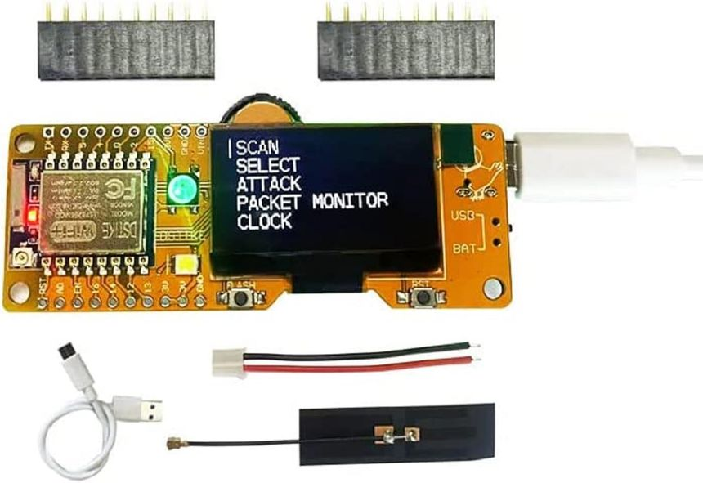

**3.2.1 *HARDWARE REQUIREMENTS***

* **ESP8266 Microcontroller**: Equipped with Wi-Fi capabilities for network monitoring.
* **Antennas**: Required for signal reception and transmission.
* **Power Source**: Reliable power supply or battery for continuous operation.
* **Optional: Enclosure or Casing**: Provides physical protection for the ESP8266 and associated components, ensuring durability and stability.

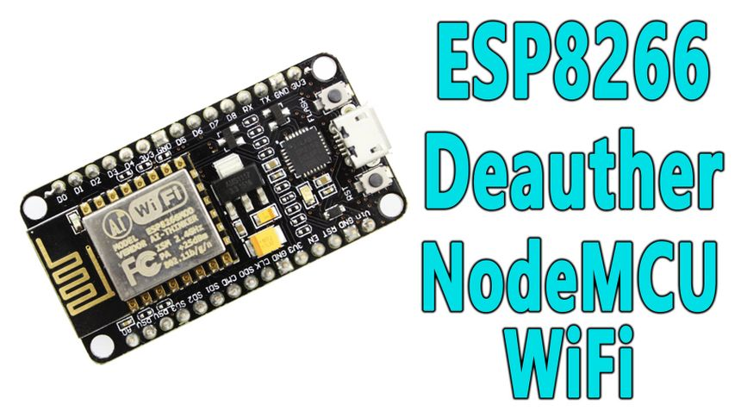

**3.2.2 *SOFTWARE REQUIREMENTS***

* **Firmware for ESP8266**: Capable of network monitoring and analysis.
* **Operating System (if applicable)**: Provides a platform for the management interface.
* **Development Environment**: Software tools for programming and configuring the ESP8266.
* **Optional: Network Monitoring Software**: Allows for advanced analysis of captured data for threat detection and prevention.

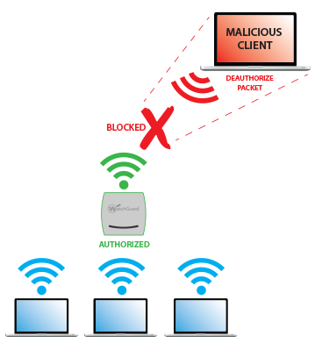

**CHAPTER 4**

**DESIGN DESCRIPTION OF PROPOSED PROJECT**

**4.1 PROPOSED METHODOLOGY**

designing a Wireless Intrusion Prevention System (WIPS) using the ESP8266 requires a systematic methodology to ensure its effectiveness in detecting and mitigating potential threats. The proposed approach encompasses several key stages:

1. Requirement Analysis: The initial phase involves a thorough understanding of the network environment. This includes identifying the types of devices in use, the layout of the physical space, and the specific security concerns unique to the network.
2. Hardware Selection and Configuration: Choosing appropriate hardware components is crucial. The ESP8266 microcontroller, with its wireless capabilities and cost-effectiveness, serves as the cornerstone. Additionally, any supplementary sensors or modules, such as RF spectrum analyzers or motion detectors, are selected based on the identified requirements.
3. Sensor Placement Strategy: Determining the optimal locations for sensor deployment is critical. This involves considering factors like the range of the ESP8266, potential interference sources, and high-traffic areas within the network. A strategic placement ensures comprehensive coverage.
4. Firmware Development: Developing custom firmware for the ESP8266 is a pivotal step. This includes programming the microcontroller to perform tasks such as packet capturing, analysis, and response triggering. Open-source libraries and existing codebases can be leveraged to expedite this process.
5. Packet Analysis Algorithms: The heart of the WIPS lies in its ability to analyze network traffic. Sophisticated algorithms are devised to inspect packets for suspicious patterns, anomalous behavior, and potential intrusion attempts. This may involve techniques like pattern recognition, anomaly detection, and signature-based identification.
6. Intrusion Detection Rules: Define rules that govern what constitutes suspicious behavior. These rules are based on the insights gained from the packet analysis algorithms. They dictate the conditions under which an alert should be triggered.
7. Alert Mechanism Integration: Establish a system for generating and relaying alerts. This could involve methods like email notifications, SMS alerts, or integration with a centralized monitoring dashboard. The timeliness and accuracy of alerts are crucial for swift response.
8. Real-time Response Strategies: Implement mechanisms for automated responses to detected threats. Depending on the severity and nature of the intrusion, responses may include actions like blocking MAC addresses, adjusting firewall rules, or temporarily isolating affected segments of the network.
9. Testing and Validation: Rigorous testing is conducted to validate the system's effectiveness. This includes simulated intrusion scenarios, sensitivity testing for false positives/negatives, and stress testing to ensure the WIPS can handle high traffic volumes.
10. Deployment and Monitoring: Once validated, the WIPS is deployed in the target environment. Continuous monitoring is crucial to ensure ongoing effectiveness. Regular audits and updates to the system's algorithms and rules are performed to adapt to evolving threats.
11. Documentation and Training: Thorough documentation of the system's architecture, configuration, and operational procedures is essential. Additionally, training is provided to network administrators and personnel responsible for overseeing the WIPS.
12. Maintenance and Updates: Establish a routine maintenance schedule for the WIPS. This includes applying firmware updates, revising intrusion detection rules, and periodically reevaluating sensor placements.
13. Requirement Analysis: The initial phase involves a thorough understanding of the network environment. This includes identifying the types of devices in use, the layout of the physical space, and the specific security concerns unique to the network.
14. Hardware Selection and Configuration: Choosing appropriate hardware components is crucial. The ESP8266 microcontroller, with its wireless capabilities and cost-effectiveness, serves as the cornerstone. Additionally, any supplementary sensors or modules, such as RF spectrum analyzers or motion detectors, are selected based on the identified requirements.

In conclusion, this proposed methodology outlines a comprehensive approach for designing a Wireless Intrusion Prevention System using the ESP8266. By following these systematic steps, network administrators can develop a robust WIPS tailored to the specific security needs of their environment, effectively safeguarding against unauthorized access and potential threats.

**4.1.1 *Ideation Map/System Architecture***

The ideation map and system architecture for the wireless intrusion prevention system (WIPS) using ESP8266 are rooted in a comprehensive approach to network security. At the core lies the ESP8266 microcontroller, leveraging its Wi-Fi capabilities to enable continuous monitoring of wireless traffic. This serves as the system's primary sensor node, capturing data for analysis. Anomaly detection algorithms form the first layer of defense, scrutinizing the traffic for irregular patterns indicative of potential threats. Once anomalies are detected, the system triggers a real-time alerting mechanism, swiftly notifying designated administrators through various communication channels. Simultaneously, automated response capabilities come into play, allowing for immediate countermeasures, such as blocking unauthorized devices or applying traffic filters. The system architecture is designed to be modular, with provisions for scalability and adaptability, ensuring it can be seamlessly integrated into diverse network environments. Moreover, a user-friendly interface facilitates easy configuration and management, while customization options cater to specific network requirements. By orchestrating these elements, the WIPS utilizing ESP8266 establishes a robust security infrastructure, fortifying wireless networks against potential intrusions with a proactive and responsive defense mechanism.

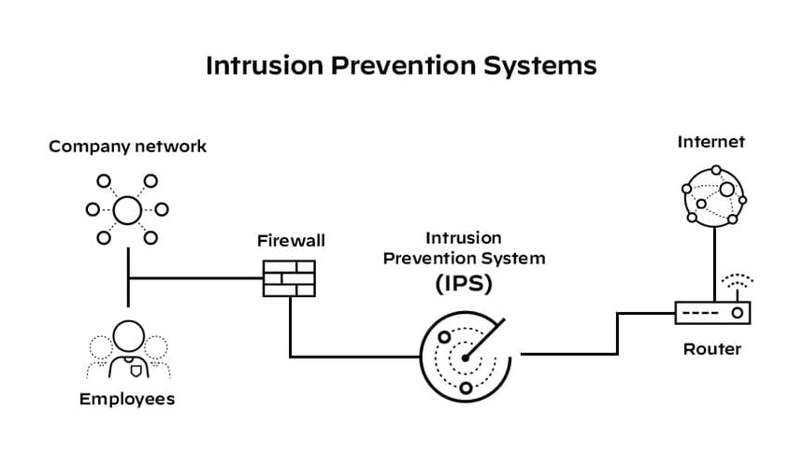

**4.1.2 *Various Stages***

The development and implementation of a Wireless Intrusion Prevention System (WIPS) utilizing the ESP8266 microcontroller entails a systematic progression through several crucial stages, each of which plays a pivotal role in fortifying the security of wireless networks.

The initial stage involves **Requirement Analysis**. This necessitates a comprehensive understanding of the network environment, encompassing factors such as the types of devices in use, the layout of physical spaces, and the specific security concerns that are pertinent to the network.

This stage lays the foundation for tailoring the WIPS to the unique characteristics and vulnerabilities of the target environment.

Following requirement analysis, the stage of **Hardware Selection and Configuration** is paramount. Here, the ESP8266 microcontroller is chosen as the central component owing to its reputation for cost-effectiveness and robust wireless capabilities.

Additionally, supplementary sensors and modules may be selected based on the identified requirements. These could include RF spectrum analyzers to scan for interference sources and motion detectors to monitor physical access points.

Next, **Sensor Placement Strategy** is determined. This stage involves strategically deploying the sensors across the environment. Factors such as the range of the ESP8266, potential interference sources, and high-traffic areas are carefully considered to ensure comprehensive coverage. Optimal placement ensures that the WIPS can effectively monitor all potential points of entry.

A pivotal stage in the process is **Firmware Development**. Custom firmware is developed for the ESP8266 to imbue it with the necessary functionality.

This encompasses programming the microcontroller to perform tasks such as packet capturing, analysis, and response triggering.

Open-source libraries and existing codebases may be leveraged to expedite this process, enabling the system to efficiently process and analyze network traffic.

The heart of the WIPS lies in its **Packet Analysis Algorithms**. Advanced algorithms are devised to inspect packets for suspicious patterns, anomalous behavior, and potential intrusion attempts.

These algorithms employ techniques like pattern recognition, anomaly detection, and signature-based identification.

They serve as the core intelligence that enables the system to discern normal network traffic from potentially malicious activities.

Simultaneously, **Intrusion Detection Rules** are established. These rules dictate what constitutes suspicious behavior based on the insights gained from the packet analysis algorithms.

They serve as the logic that guides the system's response, triggering alerts when predefined conditions indicative of a potential threat are met.

In tandem with detection mechanisms, **Alert Mechanism Integration** is implemented. This involves establishing a system for generating and relaying alerts to administrators.

Various notification methods, such as email alerts, SMS messages, or integration with a centralized monitoring dashboard, are employed to ensure that administrators are promptly informed of potential security breaches.

The stage of **Real-time Response Strategies** is critical for proactive threat mitigation. When a potential threat is identified, the system can dynamically adjust firewall rules, block suspicious MAC addresses, or even initiate temporary network isolation for the affected segment.

These automated responses serve as a vital line of defense, thwarting potential intrusions in real-time.

Subsequently, a rigorous phase of **Testing and Validation** ensues. This encompasses simulated intrusion scenarios, sensitivity testing for false positives and negatives, and stress testing to ascertain that the WIPS can effectively handle high traffic volumes. Validation ensures that the system operates reliably under diverse scenarios and provides the expected level of security.



Upon successful validation, the WIPS is ready for **Deployment and Monitoring**. The system is integrated into the target environment, and continuous monitoring commences. Regular audits and updates to the system's algorithms and rules are performed to adapt to evolving threats.

**84.1.3*****Internal or Component design structure***

The internal design structure of the wireless intrusion prevention system (WIPS) using ESP8266 is meticulously crafted to ensure seamless functionality and robust security.

At its core lies the ESP8266 microcontroller, which serves as the sensory node for capturing wireless network traffic.

This data is then processed through the anomaly detection module, where sophisticated algorithms analyze patterns to identify potential threats.

The alerting mechanism promptly notifies administrators upon detection, facilitating swift response.

Simultaneously, the automated response component is engaged, executing predefined actions against the identified threats, such as blocking unauthorized devices.

The system also incorporates a configuration interface for user-friendly setup and management, allowing for easy customization to meet specific network requirements.

Additionally, the scalability feature ensures adaptability to different network environments, while maintaining cost-effectiveness through the use of ESP8266 microcontrollers.

This carefully structured internal design empowers the WIPS to proactively safeguard wireless networks against potential intrusions.

**4.1.4 *Working Principles***

The working principle of the wireless intrusion prevention system (WIPS) utilizing ESP8266 hinges on continuous monitoring and intelligent analysis of wireless network traffic.

ESP8266 microcontrollers, equipped with Wi-Fi capabilities, serve as the system's sensory nodes.

These nodes capture data packets from the airwaves, which are then subjected to rigorous scrutiny through anomaly detection algorithms.

These algorithms discern irregular patterns or suspicious activities within the traffic, identifying potential threats.

Upon detection, the system triggers a real-time alerting mechanism, promptly notifying designated administrators. Simultaneously, automated response capabilities come into play, allowing for immediate countermeasures, such as blocking unauthorized devices or applying traffic filters.

This proactive approach fortifies the network against potential intrusions, ensuring a robust defense mechanism.

Through this intelligent interplay of hardware and software, the WIPS stands as a vigilant guardian of wireless networks, actively thwarting security breaches.

**4.2 FEATURES**

The Wireless Intrusion Prevention System (WIPS) utilizing the ESP8266 microcontroller boasts an array of advanced features that collectively fortify the security of wireless networks.

Firstly, the system's packet analysis capabilities en able it to scrutinize network traffic with precision, identifying anomalous patterns indicative of potential threats. This includes the ability to detect unauthorized access attempts, rogue devices, and suspicious data transmissions.

Moreover, the WIPS is equipped with sophisticated intrusion detection rules, empowering it to discern normal network behavior from potentially malicious activities.

Real-time response mechanisms provide a crucial line of defense, allowing the system to dynamically adjust firewall rules, block suspicious MAC addresses, and even initiate temporary network isolation for affected segments. The ESP8266's adaptability and scalability enable seamless integration into various environments, from home networks to large enterprise setups.Additionally, the system is complemented by supplementary sensors and modules, such as RF spectrum analyzers and motion detectors, extending its detection capabilities to electronic and physical intrusion attempts. Comprehensive alert mechanisms ensure timely notifications to administrators, whether through email alerts, SMS messages, or integration with centralized monitoring platforms. Rigorous testing and validation measures guarantee the system's reliability and effectiveness, including simulated intrusion scenarios, sensitivity testing, and stress tests to handle high traffic volumes. Documentation and training programs equip administrators with the knowledge and tools needed to operate and maintain the WIPS effectively. Regular maintenance, including firmware updates and rule revisions, ensures the WIPS remains aligned with evolving security needs.

**4.2.1 *Novelty of the proposal***

The proposed wireless intrusion prevention system (WIPS) leveraging ESP8266 introduces several novel elements that distinguish it from conventional security solutions. Firstly, its integration of ESP8266 microcontrollers as sensory nodes marks a cost-effective departure from traditional, often more expensive, hardware options. The system's utilization of anomaly detection algorithms, specifically tailored for wireless traffic, represents a unique approach in identifying potential threats.

Furthermore, the seamless integration with existing network infrastructure and compatibility with popular development platforms enhances its adaptability and ease of implementation. The incorporation of automated response capabilities sets it apart by enabling swift and predefined actions against identified threats, thereby ensuring a proactive security posture. Additionally, the system's user-friendly interface and customization options facilitate tailored deployment to meet specific network requirements. Finally, the scalability of the WIPS, coupled with its low-power nature, offers an efficient solution suitable for a wide range of environments, from homes to small businesses. This amalgamation of innovative features positions the proposed WIPS with ESP8266 as a forward-thinking, cost-effective, and adaptable solution in the realm of wireless network

**CHAPTER 5**

**CONCLUSION**

In conclusion, the implementation of a Wireless Intrusion Prevention System (WIPS) utilizing the ESP8266 microcontroller represents a significant stride forward in fortifying wireless networks against potential threats and unauthorized access. Through meticulous hardware selection, strategic sensor placement, and custom firmware development, this WIPS harnesses the ESP8266's wireless capabilities to monitor, analyze, and respond to network traffic in real-time. The deployment of sophisticated packet analysis algorithms, coupled with well-defined intrusion detection rules, empowers the system to swiftly identify and alert administrators to suspicious activities.

Moreover, the integration of additional sensors and modules, such as RF spectrum analyzers and motion detectors, bolsters the system's ability to detect both electronic and physical intrusions. This multi-layered approach not only enhances the system's accuracy but also broadens its scope of threat detection. The scalability of the ESP8266-based WIPS allows for seamless expansion across diverse environments, from small-scale setups to large enterprise networks.

The establishment of real-time response mechanisms further fortifies the system's efficacy. By automating actions like blocking MAC addresses, adjusting firewall rules, and isolating affected network segments, the WIPS actively mitigates potential threats before they can manifest into security breaches. This rapid and automated response capability is a crucial line of defense in today's dynamic and evolving threat landscape.

Throughout the development and deployment process, rigorous testing and validation measures ensure the system's reliability and accuracy. Simulated intrusion scenarios, sensitivity testing, and stress tests provide the assurance that the WIPS is capable of handling a wide range of real-world scenarios. Additionally, a robust documentation and training program equips network administrators with the knowledge and resources needed to operate and maintain the WIPS effectively.

In practice, the ESP8266-based WIPS stands as a versatile and cost-effective solution, adaptable to a myriad of environments and security requirements. Its continuous monitoring and adaptive nature make it a valuable asset in safeguarding wireless networks, providing peace of mind to administrators and users alike. By leveraging the ESP8266's capabilities, this WIPS sets a new standard in wireless network security, bolstering the resilience of networks in an ever-evolving digital landscape.

**REFERENCES**